Reference | Content | Review
GM6.1  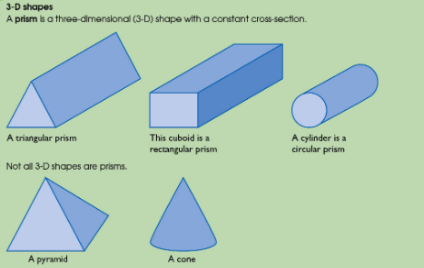 | Properties of 3-D shapes (Grade 2/3)  - Identify properties of the faces, surfaces, edges and vertices of: cubes, cuboids, prisms, cylinders, pyramids, cones and spheres.  - Use conventional terms and notations: vertices, edges, planes
GM6.2  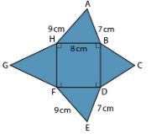 | Understanding nets (Grade 3/4)  - Identify properties of the faces, surfaces, edges and vertices of: cubes, cuboids, prisms, cylinders, pyramids, cones and spheres.  - Use conventional terms and notations: vertices, edges, planes
GM6.3  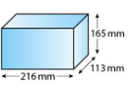 | Volume and surface area of cuboids (Grade 3/4)  - Use standard units of measure for length, area and volume  - Know and apply formulae to calculate volumes of cuboids
GM6.4  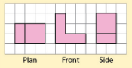 | 2-D representations of 3-D shapes (Grade 3/4)  - Interpret plans and elevations of 3D shapes
GM6.5  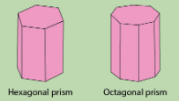 | Prisms (Grade 4/5)  - Use standard units of measure for length, area and volume  - Know and apply formulae to calculate volumes of cuboids and other right prisms (including cylinders)
GM6.6  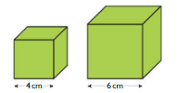 | Enlargement in 2 and 3 dimensions (Grade 4/5)  - Compare lengths, areas and volumes using ratio notation; make links to scale factors
GM6.7  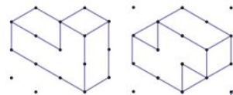 | Constructing plans and elevations (Grade 4/5)  - Construct and interpret plans and elevations of 3D shapes
GM6.8  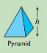 | Surface area and volume of 3D shapes (Grade 5/6)  - Calculate surface area and volume of spheres, pyramids, cones and composite solids.  - Calculate exactly with multiples of π
GM6.9  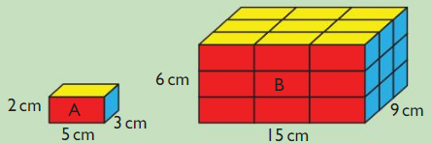 | Area and volume in similar shapes (Grade 7)  - Apply the concepts of similarity, including the relationships between lengths, areas and volumes in similar figures

Student reflection
I can now
this is something I could not do at the start of the topic.

I now understand
this is something I did not understand at the start of the topic

I need more help with
as I still have not quite understood it.

The work I am most proud of in this topic is
Because

I believe I am working at grade _______________ in this topic

